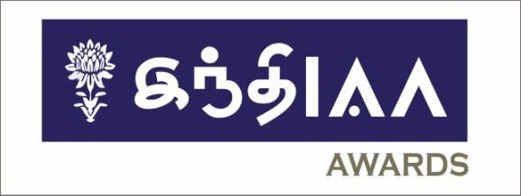

First-ever IndIAA Regional Awards – Tamil. Ogilvy does a sixer.
India Chapter of the International Advertising Association (IAA) presented its first-ever IndIAA Regional Awards (Tamil) in Chennai. The event was supported by MediaNews4u.com.
C.K.Ranganathan, CMD - CavinKare, Jury chairman-IndIAA Awards Tamil said, “Some categories saw very close competition…It was a close call.”
Mahesh Anand, President - Nippon Paints India, Jury member-IndIAA Awards Tamil said, “The amount of talent we could see was enormous.”
Murugavel Janakiraman – Founder and MD Matrimony Group, Jury member-IndIAA Awards Tamil was sure “IndIAA Awards Tamil will motivate and inspire regional brands and regional creative people”.
B R Srinivasan, Director, Vivek & Co. Jury member-IndIAA Awards Tamil said”The winners were methodically selected through a very fair process”.

Vijay Vishwanath, Founder & CEO at medianews4u.com spoke about the growth of MediaNews4U.com and thanked IAA for this opportunity.

S K Swamy, Chairman and World President, IAA Global took pride in the fact that
“IAA Global will ensure the freedom of commercial speech is protected worldwide.”

Pradeep Dwivedi, Chairman - IndIAA Regional Awards said “IndIAA Regional Awards is the epitome of recognition of creative talent and marketing execution in diverse languages of our country. IAA India will invest significant proportion of its time and effort in promoting such regional language, diversity and content.”

Sam Balsara, founder, Chairman and Managing Director of Madison World and Madison Communications, the key speaker spoke on "Challenges and Opportunities for Brands Today"
Earlier a few advertisers used to dominate ADEX. Today this is not so. 10 years the top 50 advertisers accounted for as much as 43% ADEX but today the top 50 account for only 35%.
There exists opportunity for regional and local brands as they command a high loyalty. Small brands are growing at 18.5%.
Those with entrepreneurial spirit the time to launch is now.
Some do’s and don’ts:
- Never advertise below threshold level.
- Don’t launch too many brands unless you are confident of supporting them
- Use media data as a guide not as a crutch. Use liberal doses of your gut and intuition.
- Adopt a social cause that is meaningful to the community.
- Use digital –the new age medium - Digital provides the benefit of a two way communication and is able to connect with consumers in a deeper way.
B. Srinivasan, MD, Vikatan Group spoke on regionalization of content. Indic languages are really growing.

About IAA
The International Advertising Association is the world’s only globally-focused integrated advertising trade association with membership representing Advertising agencies and the Media. The IAA comprises Corporate Members, Organizational Members, Educational Affiliates, as well as 56 Chapters with individual members and young professionals from 76 countries including the top 10 economies in the world. lAA is over 75 years’ old and is headquartered in New York.

Membership to the Indian Chapter of IAA is by invitation only and IAA has very senior marketing, advertising and media professionals as it members. IAA in India is seen as the most active chapter by IAA Global. IAA India is well-recognized for some of its marquee events like the IAA Leadership Awards, IAA Debates, IAA Conversations, IAA Young Turks Forum and an array of IAA Knowledge Seminars, Webinars, Workshops, Conclaves etc.

